المملكة العربية السعودية  وزارة التعليم  جامعة سطام بن عبد العزيز  كليه العلوم الطبية التطبيقية |  | Kingdom of Saudi Arabia  Ministry of Education  Sattam bin Abdul-Aziz University’  College of Applied Medical Sciences

Effect of hippotherapy on gait parameters in spastic hemiplegic cerebral palsied children

STUDENT’S NAME:
Albandri Alarjani
Sheikah Abdulrahman bin khunain
Nourah Alsubait

Under supervision of
DR. Alshimaa Ramadan ibrahim

Department of Physical Therapy and Rehabilitation
Sciences
College of Applied Medical Sciences

March & 2020
Abstract

-Back ground: There are a lot of data about hippotherapy but there are limited data about its effect on parameter on spastic hemiplegic cerebral palsied children.
-Objective: To investigate the effect of hippotherapy on gait parameters in spastic hemiplegic CP children.
-Methodology: Thirty spastic hemiplegic cerebral palsied children, their age ranged from 7 to 9 years old and BMI ranged from 15 to 18. They assigned into 2 group of equal number, study group (A) and control group(B). which received a designed physical therapy program, while group (A) study group received the same program in addition to hippotherapy. they were evaluated for pain by VAS and balance by Biodex balance system before and after three months of treatment.
-Result: Improvement was observed in balance in group (A), with significant difference of < 0.05.
-Conclusion: we concluded that hippotherapy is effective on improving gait parameter for spastic hemiplegic cerebral palsy.
-Keyword: (hippotherapy - gait parameters - Cerebral palsy – Hemiplegia- spastic)

List of contents
List of tables………………………………………………………….….I
List of figures………………………………………….…………......…II
List of abbreviations…………………………………...……………….II
Introduction…………………………………………………………..…8
Methodology………………………………… .……………………….14
Results………………………………………………………………..…
Discussions…………………………………………………………...…
Conclusion and recommendations……………………………….…...
References………………………………………………………………

List of tables
Table | Name | Page
1 | Swiss ball exercise
2
3
4
5

List of figures
Figure | Page
Figure 1 | 10
Figure 2 | 15
Figure 3 | 15
Figure 4 | 15
Figure 5 | 15
Figure 6 | 16
Figure 7
Figure 8
Figure 9
Figure 10
Figure 11
Figure 12
Figure 13
Figure 14
Figure 15
Figure 16
Figure 17
Figure 18
Figure 19
Figure 20

List of abbreviations:
ABB | WORD
CP | Cerebral palsy

CHAPTERE I
introduction

Introduction
Cerebral palsy (CP) is a neuromuscular dysfunction and nonprogressive disorder that occurs during early brain development and associated with abnormality posture and movement ^{[1]}.

CP is caused by brain trauma or brain malformation while the infant’s brain is under development it occurs before, during, or immediately after birth. But how a brain injury affects a child’s motor functioning and intellectual abilities is highly dependent on the nature of a brain injury where the trauma occurs, and how severe it is the causes of brain injury.

birth injury and brain malformation Infections during pregnancy, Severe untreated jaundice, Asphyxiation, Brain injury during or shortly after birth, Brain hemorrhage before birth, Infections after birth, genetic cause^{]2[}.

There are Different Types of CP: Spastic Cerebral Palsy, Athetoid Cerebral Palsy, Ataxic Cerebral Palsy, Mixed Cerebral Palsy. the most common type of CP is Spastic Cerebral Palsy, about 70-80% of CP cases. People with spastic cerebral palsy often experience exaggerated or jerky movements hypertonia. causing of Spastic CP is damaging to the brain’s motor cortex, which responses of voluntary movement. It may also cause by damaging of the pyramidal tracts help to relay signals to the muscles. And because of that spastic CP is sometimes referred to as “pyramidal”. In most studies, diplegia is the commonest form ]30% – 40 [, hemiplegia is 20% – 30%, and quadriplegia accounting for 10% – 15% ^{[3]}.

Children with CP have impairments that interfere with their motor function, physical activity, and social participation. Neuromuscular and musculoskeletal impairments include spasticity, poor balance, loss of selective motor control, and weakness ^{]4[}.

Spastic hemiplegic CP involves unilateral static lesions in regions of the brain associated with upper limb movement ^{[5]} and with motor impairments including range of motion restrictions ^{[6]}, fine motor tor coordination deficits ^{[7]}, disrupted sensory mechanisms ^{[8]}, and muscle weakness ^{[9]}. Motor impairments have a significant impact on upper limb function in children with spastic hemiplegic CP ^{[10,11]} and can severely compromise a child’s ability to perform upper limb functions such as reaching, grasping and inability to preform daily living activities such as drinking, writing, and bathing ^{[12]}.

Previous studies showed that 90% of patients with CP exhibit impaired gait patterns due to excessive muscle weakness, altered joint kinetics, and diminished postural reactions ^{[13]}. An abnormal gait caused by impairments, including upper and lower extremities developmental disability ^{[14]}, a wide base of support, short step and stride lengths, longer time is taken for single stance, and decrease velocity of walking ^{[15]}. Therefore, a common goal of rehabilitation in children with cerebral palsy is the recovery of functional gait ^{[16,17]}
Conventional approaches to the management of spastic hemiplegic CP involve medical, surgical or rehabilitative strategies ^{[18]}. With respect to rehabilitation, options typically include occupational therapy, physiotherapy, constraint induced movement therapy, resistance training, or hand-arm bimanual training ^{[19]}.

Therefore, the focus of physical therapy for children with CP is on facilitation of functional independence in activities of daily living. Various therapeutic approaches are used to achieve the best functional condition considering the degree and types of impairments, motor abilities, psychological states, and other factors ^{]20[}.

One of the new Techniques dealing with CP is Hippotherapy. And it is a technique in which a therapist uses the characteristic movements of a horse to increase neuromuscular function in patients. This therapeutic method has been used mainly for children with CP ^{]21[}. Hippotherapy provide sensory input and stimulate the upper motor neurons by rhythmic and repetitive movements of the horse. The pelvic movement of a horse during walking is very similar to that of humans ^{]22[}. Moreover, during hippotherapy, the movements of the horse combined with the warmth of the horse’s body provide deep proprioception and other sensory input and facilitate tone reduction ^{[23,24]}, and improves blood circulation, and relaxes spastic muscles in CP patients ^{]25 [}. Physical therapists are now recognizing the various therapeutic effects of hippotherapy.
in children with CP. They report increased gross motor function score, and improved balance and gait in these children ^{]26,27 [}.
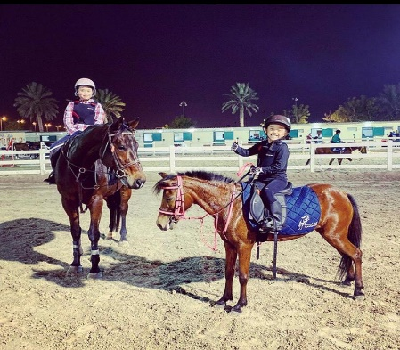
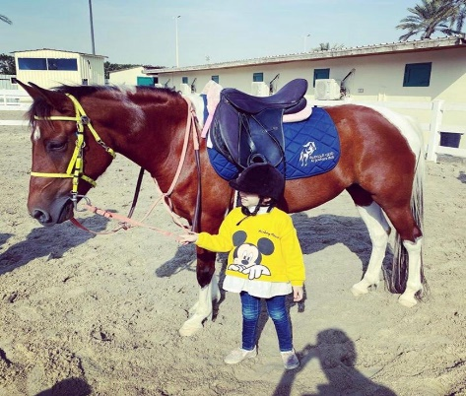

Figure [1]: hippotherapy

Statement of the study:
Does the hippotherapy improve gait parameters in spastic hemiplegic cerebral palsied children?
Purpose of the study:
To investigate the effect of hippotherapy on gait parameters in spastic hemiplegic cerebral palsied children.
Null hypothesis:
Hippotherapy has no effect in gait parameters in spastic hemiplegic cerebral palsied children.
-Delimitation:
-choose only one type (spastic, hemiplegic).
-Age from 7-9.
-mild to moderate spasticity.
-Limitation:
-a lot of type of CP.
- No age limit for CP.
-Variable degrees of spasticity.

Significant of the study:
Cerebral palsy is the most common cause of physical disability in children. CP have significant effect not only on the child but the entire family. Specifically, spastic hemiplegic CP can severely compromise a child’s ability to perform upper limb functions such as reaching, grasping, and manipulating objects, or performing activities of daily living such as eating, dressing, and bathing. It will affect lower limb which interferes with walking. there are many treatment procedures for spastic hemiplegic CP but hippotherapy maybe more accessible and adaptable and more enjoyable to children with spastic hemiplegic CP. Early rehabilitation and effective treatment will increase the motor function in both lower and upper limbs. That will promote dependency and will improve activity of daily living.

CHAPTERE II
SUBJECTS, MATERIALS &METHOD

Before we started the assessment the care giver of the subjects was requested to sign consent form that gives permission to fully participate in this study. This consent form was approved from the ethics committee college of applied medical science Sattam bin Abdul-Aziz University.
Study design:
Study was a randomized controlled trial with pretest and post-test group design. The present study was conducted at king Abdullah specialist children hospital.
Subjects:
Thirty spastic hemiplegic cerebral palsied children their age ranged from 7 to 9 years old and their BMI was from 15-18 kg/m2. They were selected from alkarj maternity and children hospital. To be included in this study children should be girls and able to walk independently the children were excluded if they have any of the following: any muscle contracture, bone deformity, mental retardation, having trunk support, showing behavioral disorders, orthopedic interventions in the last 6 months and vision and hearing defects.
Children were randomly assigned into two groups of an equal number. Group (A) study group and Group (B) control which received a designed physical therapy program, while group (A) study received the same program in addition to hippotherapy.
all children in both groups have been evaluated before and after 12 weeks of the selected programs by 3D motion analysis gait system. All children received treatment for three months for three sessions per week every session took from 30 minutes to 1 hour.
Material:
For assessment:
BMI
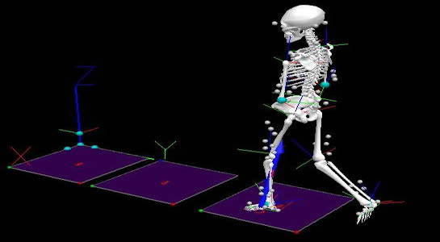
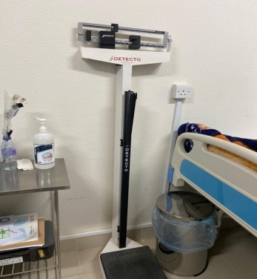

Figure [3]: weight and height scale
Figure [2]: 3D motion analysis

For treatment:
Swiss ball, wedge, roll, mat, hippo, parallel bars
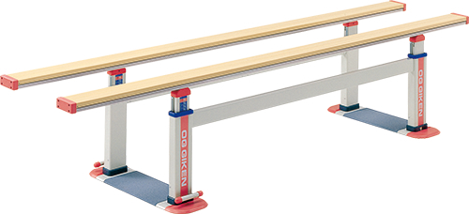
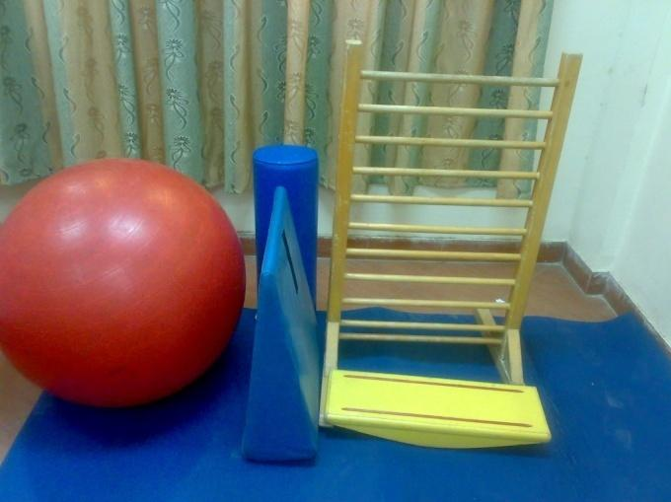

Figure [5]: parallel bars.
Figure [4]: Swiss ball, wedge, roll, mat.

saddle seat:
The horse saddle which was used in training consists of:

Leather seat: The part of the saddle where the rider sits, is modified by removing the sponge layers to allow more feeling of the horse movement.

Leather flaps: The leather straps connecting the stirrups to the saddle tree and protecting the rider’s legs from sweat.

Panel, or padding: Cushioning on the underside of the saddle to prevent harm to the horse.

Surcingle: A long strap that goes over a saddle and around the horse’s barrel to hold the saddle on.

Monkey grip: It is a handle that attached to the front of saddle. A rider may use it to maintain his or her balance or to assist in mounting

Figure [6]: saddle seat
Methods:
For assessment: All parents had been informed of all study procedures and objectives for their children with the absence of any risk. After signing a written consent form, instructions about evaluative procedures were explained for each child before the testing session to make sure that all children understood the steps of evaluation and familiar with the device.

Body Mass Index (BMI):
commonly used. Its popularity stems in part from its convenience, reliable, safety, and minimal cost, and its use is widespread, despite not being able to distinguish lean body mass from fat mass ^{[28]}. Make sure the scale is zero before patient steps onto them, let the patient remove any heavy items of clothing and shoes. Then patient stand with head straight and record the weight. Second taking height measurements in meter by using a 'drop down' tape measure fixed at about 2metres on a wall. Remove their shoes to taking the measurement and stand directly underneath the drop-down measuring device and look directly forward.
Make sure the patient stands straightly with head and upper back of shoulder all contact with wall. Lower the measuring device until it reached patient head and record the height. After measuring of height and weight we can use the main formula of the BMI by taking body weight divided by height squared (kg/m2).

3D motion analysis:
it is three-dimensional Gait analysis that measure the human gait walking patterns to identify the gait abnormalities.
using the Vicon 612 Motion Analysis System. A. We used Plug-in-Gait marker systems. Markers reflecting infrared light was applied to various landmarks on the lower extremities (anterior superior iliac spine, sacrum, lateral thigh, lateral femoral condoyle, lateral tibia, lateral ankle malleolus, posterior calcaneus, second metatarsal head). The subjects were asked to walk without shoes on a 6-m walkway in normal walking speed after the verbal command: “please walk on the walkway in your normal.” These done several times to train the subject., the subjects then walk on the walk way one last time for data collection. rest must be giving between walks to avoid fatigue. successful walking performance is achieved when markers is not obstructed for 3-dimensional reconstruction. For statistical analysis, we chose 1 of 3 walking performance to represent the gait for each subject. The Movement of body parts is taken by 6 video cameras is analyzed by biomechanical model in Vicon Clinical Manager software. For statistical analysis, we chose the affected limb, which was determined by the temporospatial parameter (shorter stride length).
Stride length the stride length was measured from the heel of the affected foot to the heel of the same foot when it again contacts the ground with the help of a measuring tape. Cadence is the steps per minutes were calculated by stop watch. Gait velocity is the normal walking speed. The gait velocity is repeated 3 times to minimize the errors ^{[29]}.

For treatment: The children representing the sample of this study were divided randomly into two groups of equal number (A and B). A designed exercise program for each child of the two groups was conducted for one hour, three times/week for three successive months, including:
Facilitation of postural reactions, including: facilitation of righting, equilibrium and protective reactions from sitting on ball.
Facilitation of standing and weight shift. - Gait training: forward, backward, and side-ways walking between parallel bars (closed environment gait training). Open gait training was also conducted.
1-swiss ball:
position | Exercise methods | Time (mintues)
Lying back over Swiss ball | Step 1. Lying on back with feet on a Swiss ball. Keeping the Swiss ball still, slowly lift bottom pushing through ankles and heels.  Perform. 3 sets of 10 repetitions. | 2
Lying prone over Swiss ball | Step 2. Lying prone over the Swiss ball with hands on the floor. Raise one arm in front of subject to shoulder height. At the same time, raise the opposite leg. Repeat this on the other side.  Perform. 3~4 sets of 10 repetitions.  Step 3. Lie face down with subject's stomach on a Swiss ball, hands on the ground out in front of subject and feet on the ground behind subject. Slowly walk subject's hands forward as subject's body peels off the ball and subject's feet rise off the ground. Keep walking subject's hands forward until subject's shins are on the ball.  Perform. Hold for 5 seconds. Rest for 10 seconds. | 3
Sit tall on Swiss ball | Step 4. Sit tall on a Swiss ball (hip and knee 90° flexion) and take subject's feet on the ground. Keeping back straight.  Perform. Hold for 20 seconds. Rest for 20 seconds.  Step 5. Sit tall on a Swiss ball (hip and knee 90° flexion) and take subject's feet on the ground. Then the therapist applies resistance to the subject in all direction.  Perform. Hold position for 5 seconds. Rest for 10 seconds.  Step 6. Sit tall on a Swiss ball (hip and knee 90° flexion) and take subject's feet on the ground. Slowly perform the pelvic tilt and circumduction exercise.  Perform. 3~4 sets of 10 repetitions.  Step 7. Sit tall on a Swiss ball(hip and knee 90° flexion) and take subject's feet on the ground. Slowly raise subject's one and/or both arms overhead with back extension.  Perform. 3~4 sets of 10 repetitions. | 3
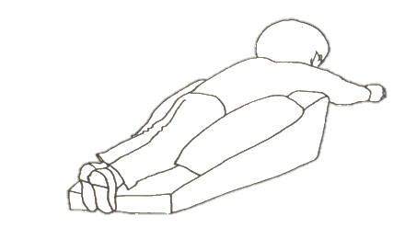

2-wedge: child is laying over in prone on the edge of the wedge and left some toys on floor to reach, and for safety sandbags can be placed on either side of the child.
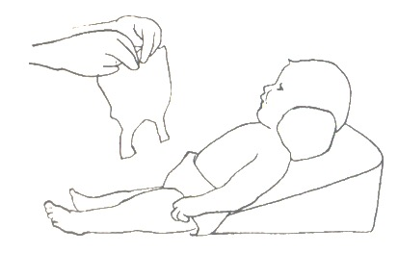
Laying supine child must have flexed their legs over the wedge to prevent dislocation if they didn’t adduction and internal rotation, this breaks up the pattern of spasticity and also gives them symmetry.
The wedge should flex their hips just enough to inhibit the spasticity ^{[30]}.
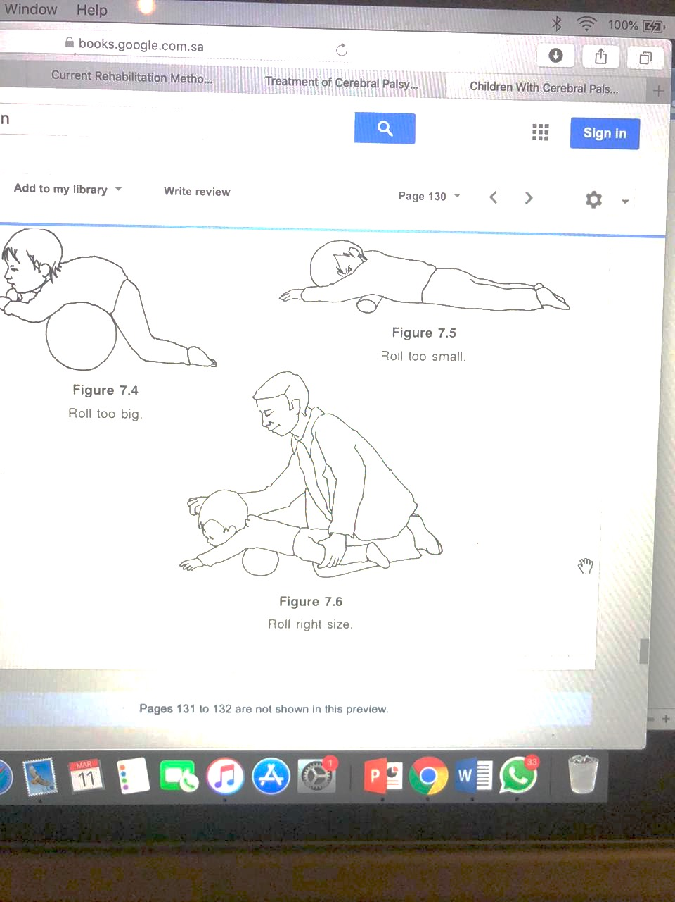
3-roll: place the child in prone with their arms elevated across a sponge rubber roll or across your lap. Hold both a child’s shoulders back and inward towards the spine for stability with symmetry in enabling active head raise and hold, rock the child forward and backward over the edge of roll or your lap to activate rising the head. Vary the speed over time ^{[30]}.
4-mat: the subject is barefoot on the mat.
raising from prone to standing: the subject is in prone position. We stand behand the subject. we ask subject to pull them self's by supporting their hands on the mat and hold them straight. then slowly flex the knees until they reach kneeling upright position. And then try to stand up by stretching their legs. Hold this position 30 seconds 3-4 sets.
Another position: from kneeling upright on the mat we place our hand under the armpits of the subject and slowly lift the subject until the legs become flat on the mat and we asked the subject to put pressure against the mat. Hold this position 30 second 3-4 sets.
Another position: we asked the subject to stand up from kneeling position while the subject put his arms on my shoulders to help him stand up. While my arms are stabilizing his pelvis. Hold this position for 30 second 3-4 sets ^{[31]}.

5-hippotherapy: In addition to the selected exercise program, group A received hippotherapy training. Horses worked during sessions with a trained experienced horse trainer. 2 physical therapists are walking along either side of the horse for assistance. Two subjects were grouped together for each session. each was assigned a separate therapist the subjects ^{[32]} .The horse gait was four-beat gait which is called walk (6.4 km/h) ^{[33]}, for every session the subject's horse walk in rectangular shape arena in clock and anti-clock direction, guided by the horse trainer who rides another horse walked in front of the subject's horse, holding the two rein lines together to direct the horses. The rhythm of the horse legs was this sequence: left hind leg, left front leg, right hind leg, right front leg, in a regular 1-2-3-4 beat. In addition, the horse moves its head and neck in a lightly up and down to keep balance ^{[33]}. The subject is rocking gently side-to-side motion in the horse’s hips as each hind leg reaches forward. We walked to the side of the horse to keep the subject safe and make sure that the subject keeps proper posture. Each subject had session riding the horse for 30 min with 10 min rest in between ^{[34]}. The first 15 min, the subject was told to grasp the monkey grip in front of him for support and to prevent loss of balance. The second 15 min, the subject sits independently, and was asked to conduct upper limb exercises in the form of unilateral upper limb elevation, extension diagonally and horizontal abduction.
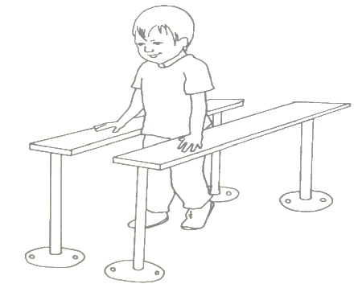
6-parallel bars: with flat board instead of handrail.
The therapist must encourage the child to grasp and hang on with their hands with a flat plank so the child can be facilitated to take weight on open hands and extended arms. Before child starts walking the length of the bars, it is useful to facilitate him to take steps sideways on the bars. Later, when he can balance with one foot in front of the other, he can learn to shift their weight from foot to foot. Children with spasticity, this weight shift will inhibit the spasticity as long as the child can walk. When the child pushes in front are likely to facilitate hip flexion and extension, so the balance will be improved ^{[30]}.

7-saddle seat: it consists of a saddle-shaped seat that keeps the hip abduction and outward rotation and it has a forward slope to facilitate anterior rotation of the pelvis ^{[35]}.
A monitor was placed in front of the saddle seat to keep the subject in place and not distracted during session. We asked the subject to sit astride comfortably on a saddle and to grasp the horn. We were standing beside the seat to assure safety. The subject was asked to actively change their posture when they feel uncomfortable. each session is 30 minutes ^{[36]}.

CHAPTERE III
Results

Results:
Thirty spastic hemiplegia cerebral palsied children. There ages ranged between (7-9) years old, height ranged ]133-137[ cm, BMI ranged (15-18) weight (23-27) kg. They were selected from alkarj maternity and children hospital. The subjects were evaluated before and after 12weeks of treatments with hippotherapy.
There were no significant differences between baseline characteristics [age, weight, BMI [ between two groups before treatment. However the analysis shows significant difference in height between the two groups.
Variables | Study ]A[ | Control ]B[ | P value | Significance
Age]ys[ | 7.93±49 | 7.87±0.46 | >0.05 | N.S
Height]cm[ | 24.93±0.82 | 25.0±0.81 | >0.05 | N.S
BMI ]kg/m^{2]} | 133.00±0.33 | 13.90±0.47 | >0.05 | N.S
Weight]kg[ | 13.9±0.36 | 23.39±0.35 | <0.05 | S
N.S: no significance. Ys: years.
Kg: kilogram. Cm: centimeter.
BMI; body mass index
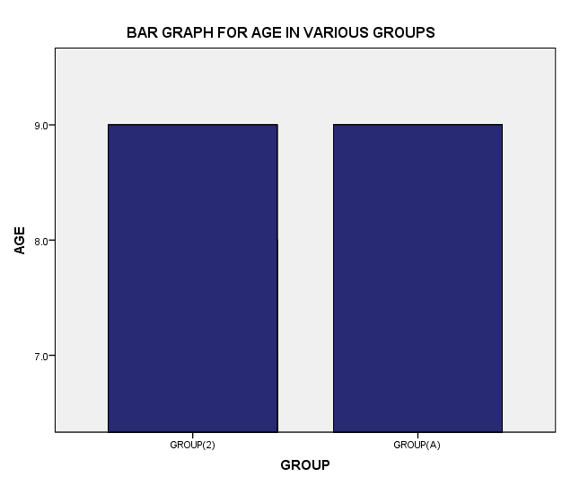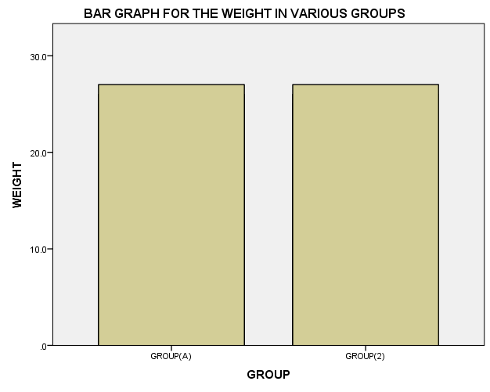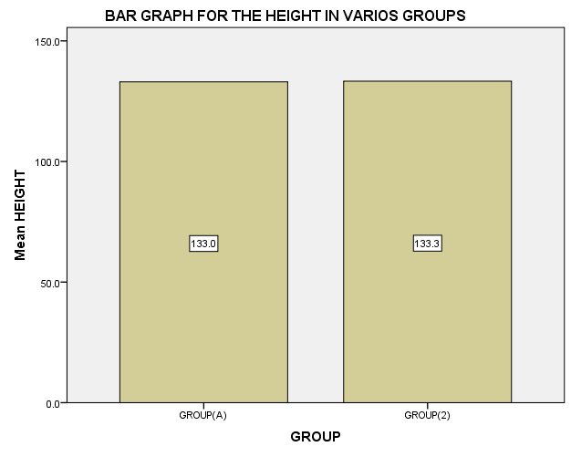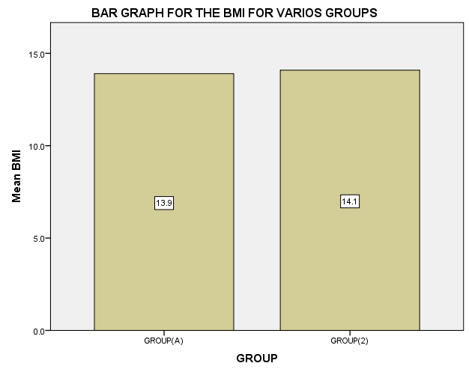

As indicated in the above test there is a statistical significance difference in height between group A and group B. However, there is no evidence to conclude difference between the two groups in terms of weight, BMI and age.

CHAPTERE IV
Discussion

Discussion:

CHAPTERE V
Conclusion and recommendations

Conclusion:
We concluded that the hippotherapy treatment was effective in improving pain and gait parameter for spastic hemiplegic cerebral palsy.

Recommendations:

We recommended that:
- Apply hippotherapy for different types of CP.
- Apply hippotherapy for another parameter.
- Apply hippotherapy other neurological disorders.
- Apply hippotherapy for older age group.
- Apply in a large sample.

CHAPTERE VI
references

references:

